1. **Create user management**

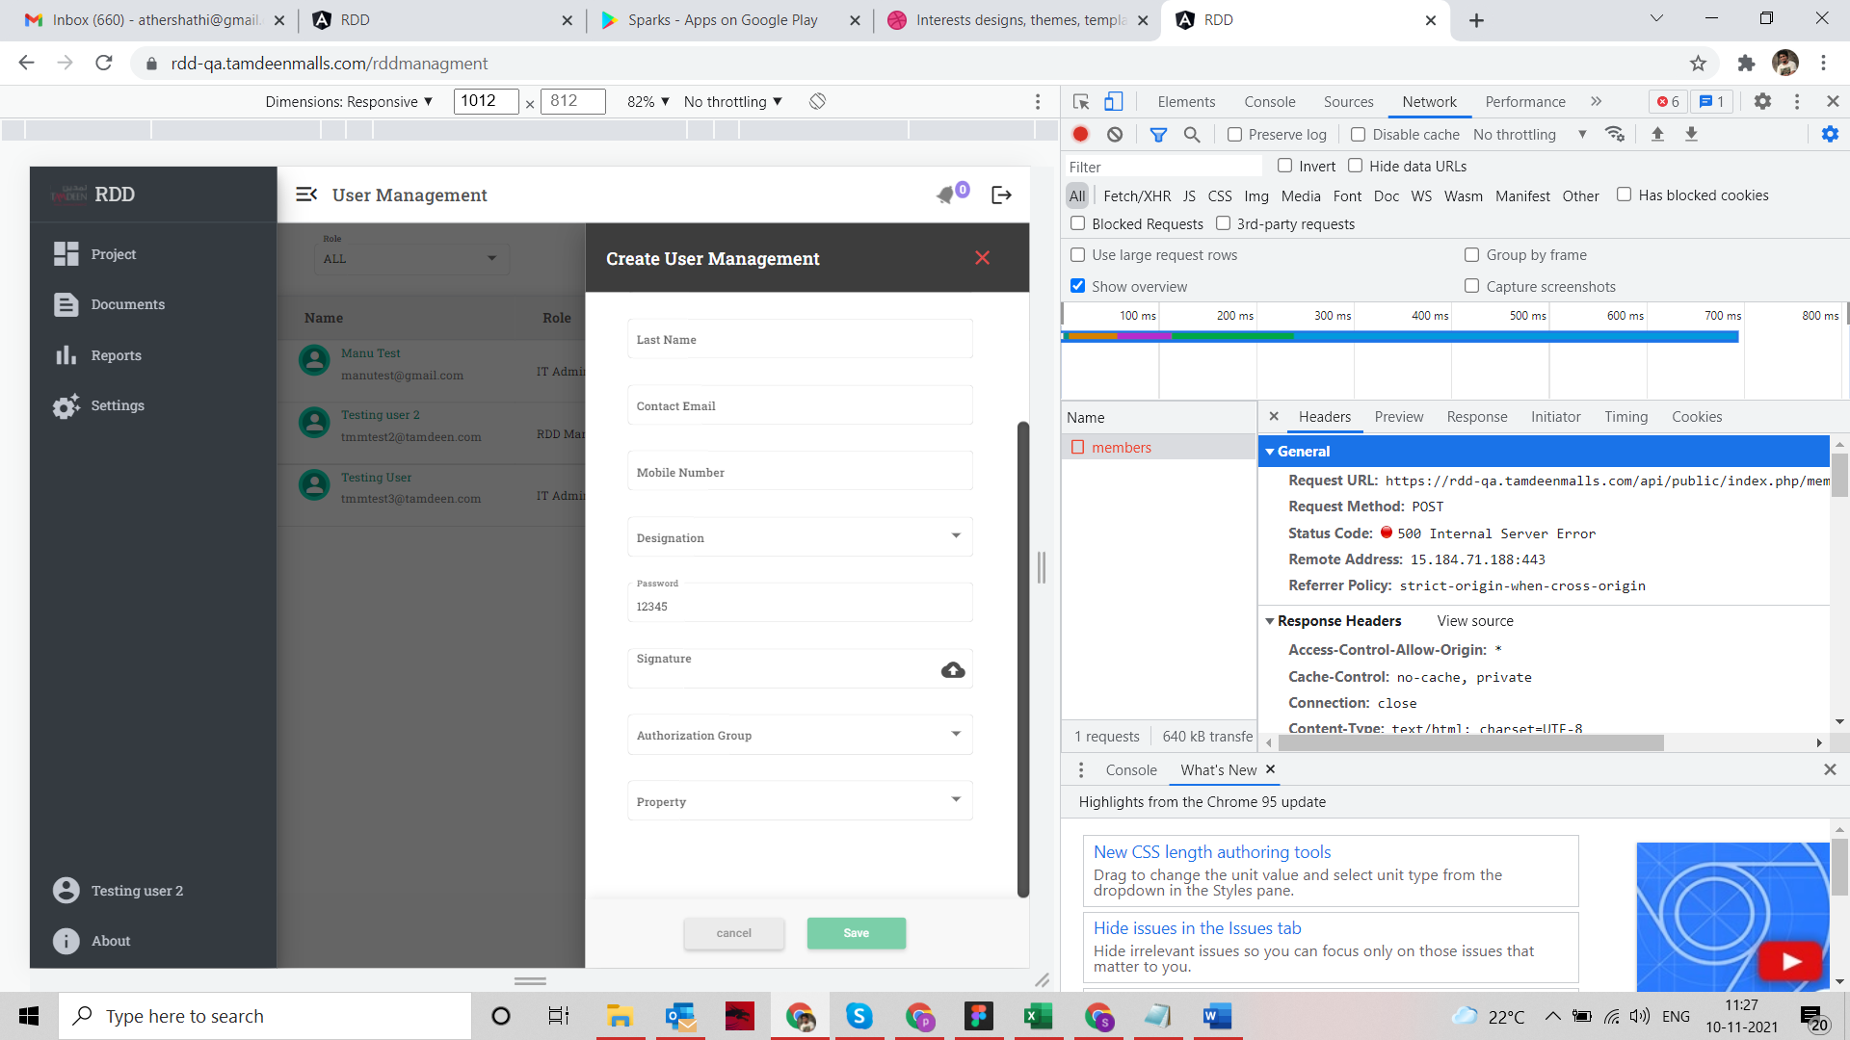

Illuminate\Database\QueryException: SQLSTATE[23000]: Integrity constraint violation: 1048 Column 'mem_signature_path' cannot be null (SQL: insert into `users` (`mem_org_id`, `mem_name`, `mem_last_name`, `email`, `password`, `mobile_no`, `gender`, `mem_designation`, `mem_signature_path`, `mem_level`, `auth_grp`, `properties`, `created_at`, `updated_at`, `access_type`) values (1, test4, Joesph, shadoox.biz@gmail.com, $2y$10$vKAr8GARfb0aMPXuR9C47upsdJvHBEkDJLVd.fJtSNu9qpxyIkIk6, 12976542, 0, 5, ?, 5, 1, [1], 2021-11-10 05:55:30, 2021-11-10 05:55:30, 6)) in file /var/www/html/rdd_portal_qa/api/vendor/laravel/framework/src/Illuminate/Database/Connection.php on line 703

#0 /var/www/html/rdd_portal_qa/api/vendor/laravel/framework/src/Illuminate/Database/Connection.php(663): Illuminate\Database\Connection->runQueryCallback()

#1

1. **Project type**

ErrorException: chmod(): Operation not permitted in file /var/www/html/rdd_portal_qa/api/app/Http/Controllers/DocumentController.php on line 36

#0 [internal function]: Illuminate\Foundation\Bootstrap\HandleExceptions->handleError()

#1

